- Version of WinSCP you are using (you should be using the latest version if possible).
*Downloaded Version WinSCP 5.15.1
- If the problem started to occur after upgrade, mention the last version of WinSCP which was working for you.¹
*Problem started occurring after we disabled the following: Enable transfer resume/transfer to temporary filename for. Instructions provided to us by our software vendor, Ultimate Software.
- Version of Microsoft Windows you are running WinSCP on.
*Edition Windows 10 Enterprise. Version: 1511
- Transfer protocol (SFTP, FTP, SCP, WebDAV or S3).
*SFTP
- Mention if you use GUI or scripting/automation. If you use GUI, specify interface style you are using (Commander or Explorer).
*Unsure
- If you experience an error, include full error message. You may use Ctrl+C to copy the message, then paste it (Ctrl+V) to the post.
*No error message displays
- Try to describe precise steps that lead to the problem (where do you click, what keys do you press, what do you see, etc.). If you are not able to reproduce the problem with the steps, it is probably not worth to report it as I will not be able to reproduce it (and solve) too.
Particularly, if the problem relates to user interface, consider recording your steps or even full video. E.g. using Steps Recorder in Windows 7 or newer² or Start recording function of Game bar in Windows 10³ or Recordit or similar service.
*When attempting to move multiple documents into the SFTP I click Ctrl+A and then Ctrl+C the paste using Ctrl+V. During the pasting if even though I have copied multiple documents only one document will appear. See screen shot below. I tried moving the documents over again but it will only replace that one document with another, seemingly at random.
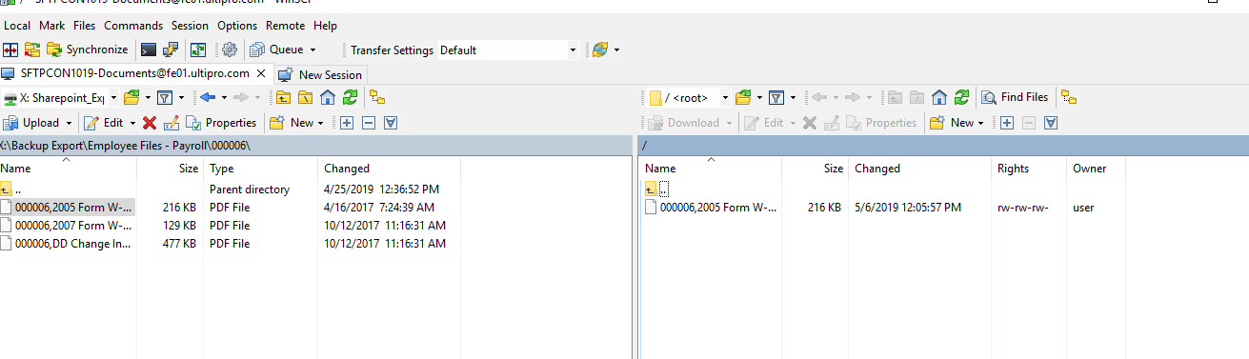
- If your problems relates to interaction with remote server, please post a full log file showing the problem.
To generate log file, enable session logging, log in to your server and do the operation and only the operation that causes the error.
Always attach your log to the post as a file, never paste the log into post text. When posting extensive logs please compress them before attaching.
Note that passwords and passphrases are not stored in the log. You may want to remove other data you consider sensitive though, such as host names, IP addresses, account names or file names (unless they are relevant to the problem).
If you do not want to post the log publicly, you can mark the attachment as private.
*Unsure
- For scripting/automation-related issues, include your full script, command-line you use to run WinSCP, and output you see on WinSCP console.
*Unsure

